Team 5 Tiny Homes 448/548
Seam 7 Competency Grid Releasing the untapped potential of enterprises through socio-economic management in PDF
HC book Ch 5
Agile pp. book 66-74

“Agility is what allows an organization to respond in a more timely, effective, and sustained way than their competitors when changing circumstances require it” (p. 66).

Agility Standards from AGILE BOOK pp. 66-74

- Outcome Standard –Tiny Homes (http://veteranstheater.com) clearly demonstrates they have adapted to both the City and NMSU in an attempt to get affirmative answer to Tiny Homes Eco-Village start up. Adaptability means being able to change over and over again (p. 67). Tiny Homes Eco-Village (Phase I) changed from locating off-campus to proposing A-Mountain location by Rodeo, and on-campus replacing old 1950s housing units with new Tiny Homes. And (Phase II) for City changed from several proposed locations to Burn Lake, as a Tiny Homes for formerly homeless veterans and their families. The current obstacle at NMSU is Board of Regents are considering plan to expand NMSU golf course to 27 holes, which would cancel the Rodeo site by A Mountain. NMSU is also considering privatizing all student housing (all dorms, all units) to a private corporation. Only way around blocks to Phase I, is to resist Golf Course expansion, and resist further privatization. Phase II can move into action, once Army Corps of Engineers is done renovating Burn Lake. Veterans Theater has demonstrated robust initiative in adapting to the blocks to its proposals.
- Organization Standard – Does Tiny Homes Eco-Village possess strategies, structures, systems, and processes to change its perform consistently. The student intervention team (#5 in Mgt 448) is helping in this area. Team 5 is working with David Boje, Ernest Ramey, Shannon Reynolds, and Gavin Clarkson to focus the change decisions, teach them the SEAM tools, and analyze their business plan. The first principle of the organization standard is to use two phases onf Tiny Homes implementation, to decentralize the sites (one or two at NMSU, and one in City). To support this principle the Tiny Homes Eco-Villages meet to keep everyone in direct contact. There have been 2 main meetings with NMSU (Arrowhead, Facilities & Services), and 2 main meetings with City Council, and presentations to veterans Advisory Council to the Mayor, to American Legion Post 10, and so on. Decentralization allows a variety of location choices to emerge for the Ec-Villages. In addition there are three kinds of Tiny Homes designs (trailer mounted design of NMSU Engineering students), a modular assembled unit with a model up & now on display), and Ramey’s idea for a concrete application construction option. The Eco-Villages have a synchronized strategic vision (Agile, p. 69). Each proposed site location contributes to the strategy’s implementation. Meanwhile there is strategic vigilance process to follow developments at NMSU and in the city. Focus groups with student veterans at NMSU (potential customers) and with homeless and homeless veterans in the city (different group of potential customers) would be a way forward. The Veterans Theater Eco-Villages projects are well on their way to establishing agility routines, differentiating capabilities driving performance to build a strong foundation at both NMSU and the City. They are using local sourcing for Tiny Homes construction, continuing fundraising on YouCaring site, doing local theater plays on homeless and veterans issues to keep up awareness of projects. IN short, they have an effective environmental scanning process. They need an actual written Priority Action Plan (PAP), which 448/s Team 5 can help implement. Also need IESAP, Competency Grid, and PNAC tools. This will help the client to continue to be Agile.

April 4 2016 - presentation on Eco-Village for Veterans to the City Council of Las Cruces see PowerPoint Slides.
April 10 2016 - Tiny homes subdivision proposed to city officials article by Steve Ramirez, Las Cruces Sun-News7:04 p.m. MDT April 9, 2016
September 15, 2016 - Veterans Eco Village presentation to Arrowhead 16 September 2016
The November 23 2016 Plan for two Veterans Eco Villages, Phase I -Rodeo Property A-Mountain for Legacy Ranch and the Student Veterans' Eco- Village of Tiny Homes; Phase II - Burn Lake City of Las Cruces for Homeless Veterans (and Other Homeless). This is for the next meeting of NMSU Board of Regents - Real Estate Committee presentation.
Veterans ECO Village of Las Cruces Modular Construction YouTube
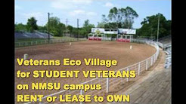
8:53

Veterans Ecological Villages for Las Cruces NEW MEXICO

New Las Cruces theater group gives voice to veterans, homeless
By Mike Cook
Las Cruces Bulletin, 5 February, 2016
See the above items at http://veteranstheater.com or click directly

Today’s focus is Competency Grid in the Online Releasing the untapped potential of enterprises through socio-economic management in PDF See COMPETENCY GRID TOOL form in main syllabus of 448/548

Hidden Costs book (Mgt 548) Chapter 5. “The Socio-Economic Diagnostic” chapter applied to ‘Tiny Homes Eco-Villages’ project of Team 5.

“The socio-economic diagnostic is first and foremost a process of listening to all actors involved” (p. 127). This is the Eco-Villages key members:
- David M. Boje Ph.D. (Veteran, Army; Regents Professor at NMSU; American Legion Post 10; President Antenarrative Not-for-profit Foundation 501 c 3), co-developer of Veterans’ Eco-Village
- Shannon Reynolds (Veteran, Air Force), co-developer of Veterans’ Eco-Village
- Hector Sanchez (Veteran, Air Force), Director Military & Veteran Services at New Mexico State University
- Jesus Oropeza, (Veteran, Navy), Builder Tropicana [modular panel construction] Homes co-developer of Veterans’ Eco-Village
- Professor Gavin Clarkson, Business Law, NMSU, partner with Jesus Oropeza
- Ernest Ramey (Veteran, Army; Veterans Theater President; Officer of Antenarrative Foundation 501 c 3)
- Students at NMSU: Mabel Sanchez (Ph.d. Program), David Perez (MBA program), Paloma Villalobos (Undergraduate program) NMSU
- Walter F. Baker (Retired Captain, Navy; American Legion Post 10) & Chaplain Lawrence Orvis (Veteran, Army; American Legion Post 10)

We witness dysfunctions, and seek to address their causes, reduce the dysfunctions. This takes a proactive diagnostic.
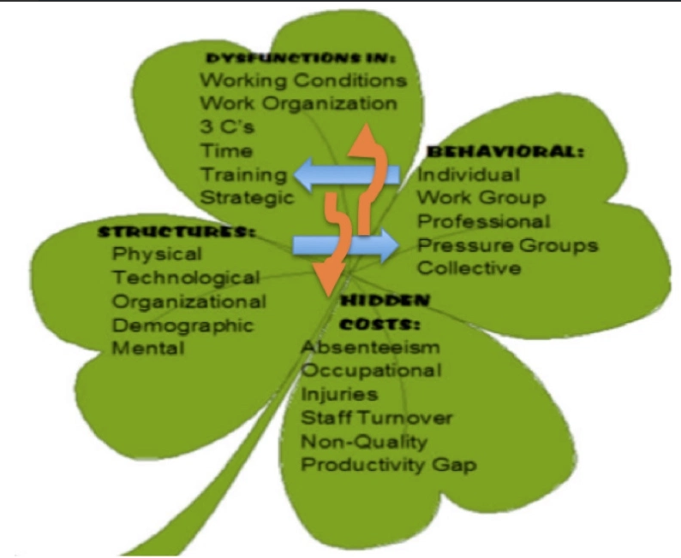
Figure 1: Diagnostic Tool of SEAM
Source: https://davidboje.wordpress.com/2017/02/25/how-to-develop-a-university-of-the-future-at-new-mexico-state-university/

This begins with a conference among the Tiny Homes Eco-Villages actors, and an interview process by Team 5 with those actors. The Team 5 (448) can encourage expression of opinions on the operation, and one-on-one interviews can promise anonymity. Critical listenting is important in this process. After listening, the Team 5 can develop their own expert opinions (3 recommendations as part of Mirror Effect. This also include a Table of the key dysfunctions, the Hidden cost Calculations, etc. see next example.
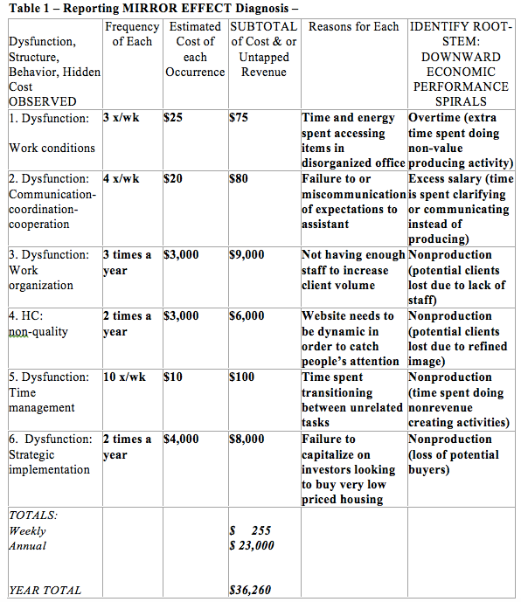

This example comes from 448/548 report template at TEMPLATE IN WORD FOR YOUR TEAM's TERM PAPER (its an actual compilation of best reports; you edit it an put in your own stuff from your consultations located at course syllabus.

Regulations are how an organization tries to compensate for their Hidden Costs, such as by putting additional micromanagement (close supervision in place), more overtime, more rework, etc. The problem is this regulation approach does not resolve the root causes of the Dysfunctions, so they continue, and the Regulation stop gaps add more Hidden Costs.

Elementary Dysfunctions Regulations Hidden Costs
See p. 129 Figure 5.1

“Dysfunctions provoked and regulated by the micro-space itself” (p. 129) get externalized (affect lack of a site for Tiny Homes villages agreed to by Board of Regents or by City of Las Cruces), and the root causes of this dysfunction are located in a micro-space that is as yet un-diagnosed, unexamined, and not reflected upon by the Eco-village members (see above list). Hidden Costs are endured, and increasing because in-depth studies of “multiple micro-spaces” have not yet been done (p. 130). For example, NMSU has been approached by a developer of Golf Courses and by a Privatizer of Resident Housing. Until the micro-space of NMSU Board of Regents (appointed by Governor Marinez) makes a final decision, there can be no movement on approval of the Tiny Homes Eco-Villages at NMSU. The root cause of this dysfunction are in three micro-spaces: (1) lack of participative democratic governance, (2) lack of transparency in strategic planning decisions, and (3) intensive TFW Virus infecting NMSU. See https://davidboje.wordpress.com/2017/02/25/how-to-develop-a-university-of-the-future-at-new-mexico-state-university/ for more on these root causes (micro-spaces).

In sum, Team 5 (Mgt 448) can do data collection training of the Eco-Village members to study the micro-spaces producing Hidden Costs. This includes doing a Mirror Effect with Expert Opinion, doing one-on-one interviews with personnel, doing interviews with City Council, and with NMSU Board of Regents. These last two are the personnel within the Micro-Spaces where a diagnostic is most needed. Team 5 can also collect online documents of NMSU Master Plan, and attend meetings of Board of Regents (http://masterplan.nmsu.edu/ and https://regents.nmsu.edu/).

This will facilitate analysis of micro-spaces, to get at root causes of dysfunctions, and to calculate the accumulating Hidden Costs of Regulation (stop gap measures that don’t get at the root of the Situation). Themes and subthemes of the interviews, document analysis, and direct observations of Team 5 can go along way to getting at STEM ROOTS.

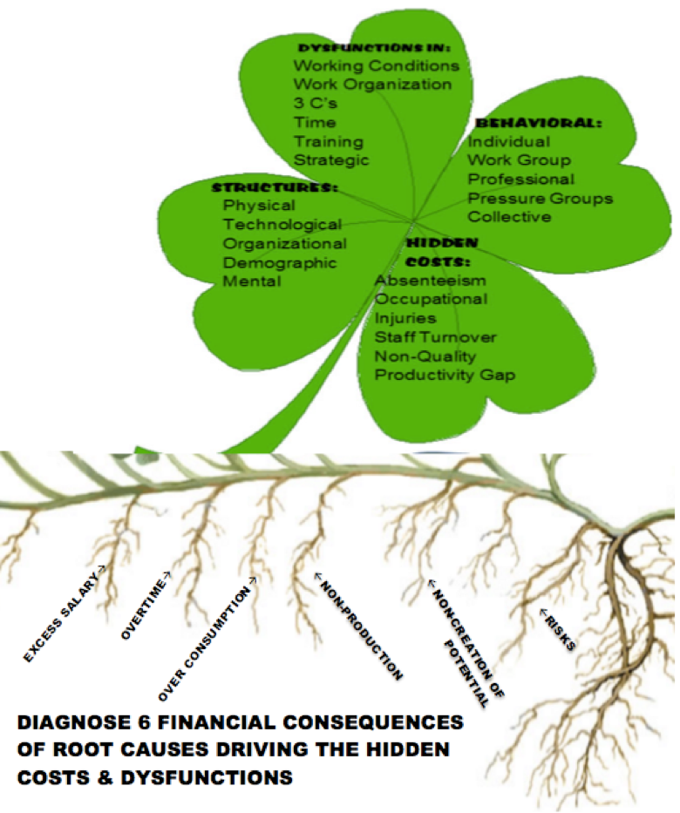
Figure 2 – Diagnostic 4-Leaf with Six Stem Roots

For example, in Micro-Space of NMSU, there is Excess Salary paid because of the Deloitte consulting firm downsizing of staff. NMSU faculty and staff remaining are doing overtime to carry out the work load of missing people (who have left, been force out, or dismissed in the reorganization). There is over-consumption of resources (waste of potential for Eco-Villages at NMSU, efforts to move Rodeo away form the impending 27 hole golf course proposal).
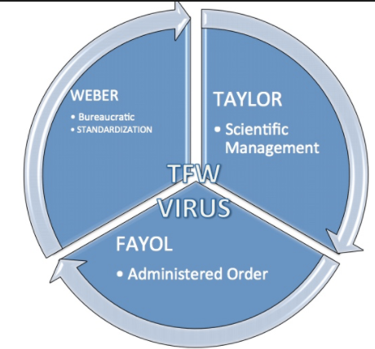
Figure 3 – TFW Virus in SEAM Diagnostic of Hidden Costs

Meanwhile there is non-production for the Tiny Homes initiative at NMSU, there is non-creation of Tiny Homes potential for lower cost student housing in ecological village. There are RISKS that NMSU will not able to sustain a participative democracy, achieve Ensemble of Leadership, and get a cure to the TFW virus.

